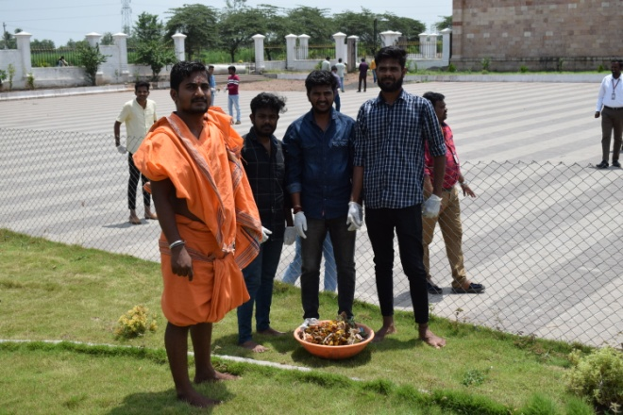  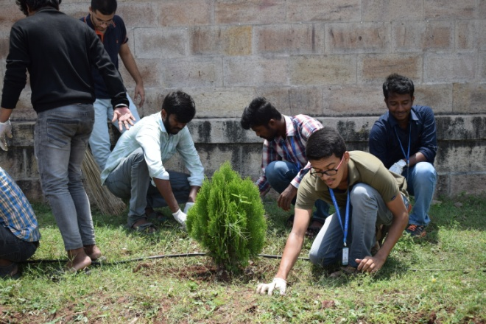  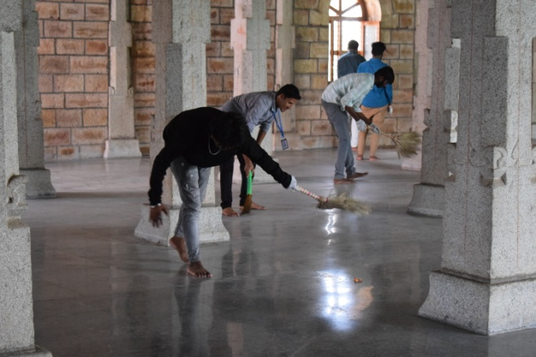 | 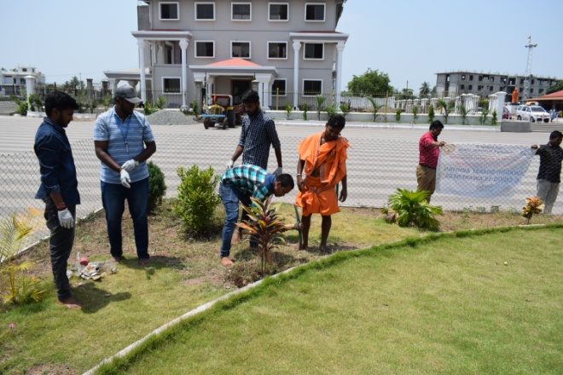  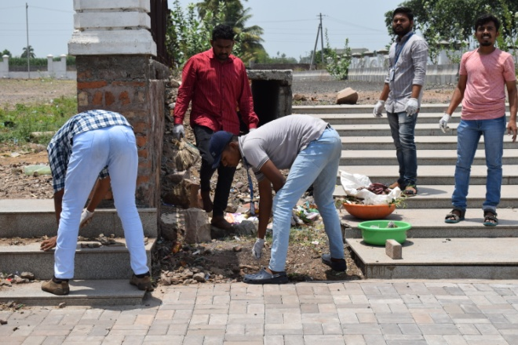  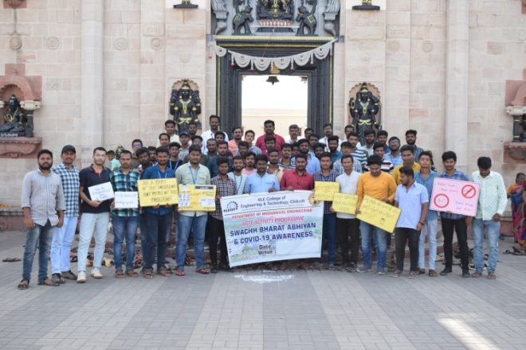
An AICTE Activity program for 6th Sem Mechanical Engineering Students was held on May 5th, 2022 at Shri Gurupadeshwar Math, Mugalkhod.

